Amend\View a Customer

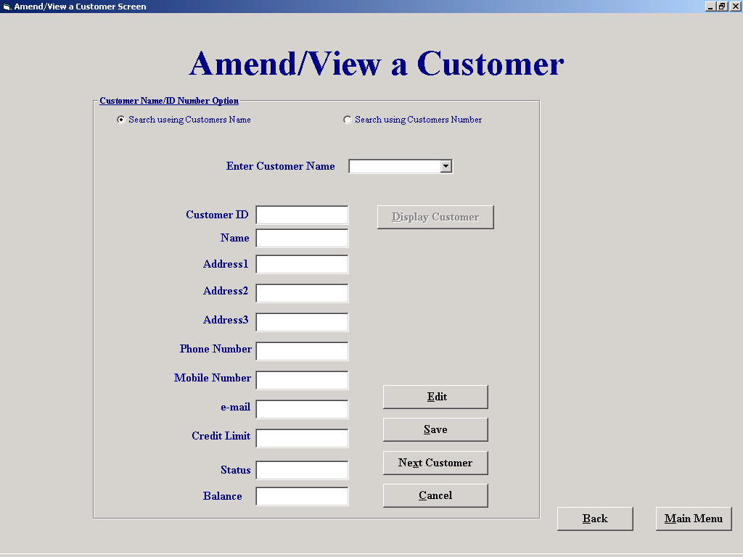

'Purpose This form allows the user to select a customer either by
' picking a customer ID from a drop down list,picking a
' customer name from a drop down list or by entering part of
' a name and searching through any names that match the criteria
' The Customers details can then be saved or ammended. If a
' customers details are amended they will be temperarly stored
' in the associated tag of the relevent text box until the save
' comand is selected. If the cancel comand is selected then all
' amendments not saved will be deleted
'Student David Hamilton
'StudentID Com2023
'Last Modified 15/3/02

'Variables used
'varName Variant
'varAdd1 Variant
'varAdd2 Variant
'varAdd3 Variant
'varPhone Variant (Declared as a varant because they are being
'varMob Variant used with the split Function)
'varEmail Variant
'varCrLim Variant
'varNum Variant
'strName String
'strID String
'intID Integer
'intNumber Integer
'intSaveCount Integer(Form level)

Option Explicit

Dim intSaveCount As Integer
'Clears the screen, clears the tags and resets the form level variabl
'intSaveCount to 0

Private Sub cmdBack_Click()
frmCustomerFileProcessing.Show
Unload Me
End Sub

Private Sub cmdCancel_Click()

ClearAll 'Procedure to clear Input boxes

If txtNameFound.Tag <> "" Then
txtNameFound.Tag = ""
txtAddress1.Tag = ""
txtAddress2.Tag = ""
txtAddress3.Tag = ""
txtPhoneNo.Tag = ""
txtMobileNo.Tag = ""
txtEmail.Tag = ""
txtCreditLimit.Tag = ""
intSaveCount = 0
End If
End Sub

'Enables relevent text boxes to allow editing
Private Sub cmdEdit_Click()

txtNameFound.Enabled = True
txtAddress1.Enabled = True
txtAddress2.Enabled = True
txtAddress3.Enabled = True
txtPhoneNo.Enabled = True
txtMobileNo.Enabled = True
txtEmail.Enabled = True
txtCreditLimit.Enabled = True

End Sub

Private Sub cmdMainMenu_Click()
frmMainMenu.Show
Unload Me

'selecting this button allows you to display another Customer
'The inputs are not saved at this stage but
'instead moved to the tags of the relevent text boxes, the
'text boxes are then cleared to make way for the next inputs
Private Sub cmdNextCustomer_Click()
If txtNameFound.Tag = "" Then
txtCustID.Tag = txtCustID
txtNameFound.Tag = txtNameFound
txtAddress1.Tag = txtAddress1
txtAddress2.Tag = txtAddress2
txtAddress3.Tag = txtAddress3
txtPhoneNo.Tag = txtPhoneNo
txtMobileNo.Tag = txtMobileNo
txtEmail.Tag = txtEmail
txtCreditLimit.Tag = txtCreditLimit
intSaveCount = 1
Else
txtCustID.Tag = txtCustID.Tag & Chr(9) & txtCustID
txtNameFound.Tag = txtNameFound.Tag & Chr(9) & txtNameFound
txtAddress1.Tag = txtAddress1.Tag & Chr(9) & txtAddress1
txtAddress2.Tag = txtAddress2.Tag & Chr(9) & txtAddress2
txtAddress3.Tag = txtAddress3.Tag & Chr(9) & txtAddress3
txtPhoneNo.Tag = txtPhoneNo.Tag & Chr(9) & txtPhoneNo
txtMobileNo.Tag = txtMobileNo.Tag & Chr(9) & txtMobileNo
txtEmail.Tag = txtEmail.Tag & Chr(9) & txtEmail
txtCreditLimit.Tag = txtCreditLimit.Tag & Chr(9) & txtCreditLimit
intSaveCount = intSaveCount + 1
End If

ClearAll 'Procedure to clear Input boxes
End Sub

'Allows the user to search through all records which match the initial criteria
Private Sub cmdPrevious_Click()

Dim strName As String

strName = cboName.Text
datCustomer.Recordset.FindPrevious ("Name like '*" & strName & "*'")

DisplayCustomer ' Displays the customer that relates to the above criteria
End Sub

'clears the text boxes and sets the "Enabled" settings of relevent input boxes
Private Sub ClearAll()
txtCustID = ""
txtNameFound = ""
txtAddress1 = ""
txtAddress2 = ""
txtAddress3 = ""
txtPhoneNo = ""
txtMobileNo = ""
txtEmail = ""
txtCreditLimit = ""
txtStatus = ""
txtBalance = ""

fmeMove.Visible = False
optName = True
cboName.Text = ""
cboNumber.Text = ""
optName.Enabled = True
optNumber.Enabled = True
cboName.Enabled = True
cmdSeekCustomer.Enabled = True
cboName.SetFocus
End Sub

'Allows the user to search through all records which match the initial criteria

Private Sub cmdNext_Click()
Dim strName As String

strName = cboName.Text
datCustomer.Recordset.FindNext ("Name like '*" & strName & "*'")

DisplayCustomer ' Displays the customer that relates to the above criteria

End Sub

'Saves the information presently displayed in the relevant
'input boxes as well as the information stored in their associated tags
Private Sub cmdSave_Click()
Dim intNumber As Integer
Dim varName, varAdd1, varAdd2, varAdd3, varPhone, varMob, varEmail, varCrLim, varNum As Variant

intResponse = MsgBox("Click OK to save all inputted Data", vbOKCancel, "SAVE NOW")
If intResponse = 1 Then

If txtCustID.Text <> "" Then
intNumber = Int(Val(txtCustID.Text))
datCustomer.Recordset.FindFirst "Cust_ID = " & intNumber & ""
datCustomer.Recordset.Edit
datCustomer.Recordset("Name") = txtNameFound
datCustomer.Recordset("Address 1") = txtAddress1
datCustomer.Recordset("Address 2") = txtAddress2
datCustomer.Recordset("Address 3") = txtAddress3
datCustomer.Recordset("Phone No") = txtPhoneNo
datCustomer.Recordset("Mobile No") = txtMobileNo
datCustomer.Recordset("E-Mail") = txtEmail
datCustomer.Recordset("Credit Limit") = txtCreditLimit
datCustomer.Recordset.Update

ClearAll 'Procedure to clear Input boxes

End If

If txtNameFound.Tag <> "" Then
If InStr(txtNameFound.Tag, Chr(9)) <> 0 Then
varNum = Split(txtCustID.Tag, Chr(9))
varName = Split(txtNameFound.Tag, Chr(9))
varAdd1 = Split(txtAddress1.Tag, Chr(9))
varAdd2 = Split(txtAddress2.Tag, Chr(9))
varAdd3 = Split(txtAddress3.Tag, Chr(9))
varPhone = Split(txtPhoneNo.Tag, Chr(9))
varMob = Split(txtMobileNo.Tag, Chr(9))
varEmail = Split(txtEmail.Tag, Chr(9))
varCrLim = Split(txtCreditLimit.Tag, Chr(9))

For intIndex = 0 To intSaveCount - 1
intNumber = Val(varNum(intIndex))
datCustomer.Recordset.FindFirst "Cust_ID = " & intNumber & ""
datCustomer.Recordset.Edit
datCustomer.Recordset("Name") = varName(intIndex)
datCustomer.Recordset("Address 1") = varAdd1(intIndex)
datCustomer.Recordset("Address 2") = varAdd2(intIndex)
datCustomer.Recordset("Address 3") = varAdd3(intIndex)
datCustomer.Recordset("Phone No") = varPhone(intIndex)
datCustomer.Recordset("Mobile No") = varMob(intIndex)
datCustomer.Recordset("E-Mail") = varEmail(intIndex)
datCustomer.Recordset("Credit Limit") = Val(varCrLim(intIndex))
datCustomer.Recordset.Update
Next intIndex
cmdCancel_Click

Else
intNumber = Val(txtCustID.Tag)
datCustomer.Recordset.FindFirst "Cust_ID = " & intNumber & ""
datCustomer.Recordset.Edit
datCustomer.Recordset("Name") = txtNameFound.Tag
datCustomer.Recordset("Address 1") = txtAddress1.Tag
datCustomer.Recordset("Address 2") = txtAddress2.Tag
datCustomer.Recordset("Address 3") = txtAddress3.Tag
datCustomer.Recordset("Phone No") = txtPhoneNo.Tag
datCustomer.Recordset("Mobile No") = txtMobileNo.Tag
datCustomer.Recordset("E-Mail") = txtEmail.Tag
datCustomer.Recordset("Credit Limit") = txtCreditLimit.Tag
datCustomer.Recordset.Update
cmdCancel_Click
End If
End If
Else
cmdCancel_Click
End If

End Sub

'When the form is loaded drop down lists of both cboName and cboNumber are
'filled from the customer table
Private Sub Form_Load()
datCustomer.DatabaseName = "G:\EqpthireProject\EHS.mdb"
datCustomer.RecordSource = "Customer"
datCustomer.Refresh

While Not datCustomer.Recordset.EOF
cboName.AddItem datCustomer.Recordset("Name")
cboNumber.AddItem datCustomer.Recordset("Cust_ID")
datCustomer.Recordset.MoveNext
Wend

End Sub

Private Sub optName_Click()

lblNameNumber = "Enter Customers Name"
cboName = ""
cboName.Visible = True
cboNumber.Visible = False
cboName.Enabled = True
cboName.SetFocus

Private Sub optNumber_Click()

lblNameNumber = "Enter Customers ID Number"
cboName.Visible = False
cboNumber.Visible = True
cboNumber = ""
cboNumber.Enabled = True
cboNumber.SetFocus

End Sub

Private Sub cboName_Change()
cmdSeekCustomer.Enabled = True
End Sub

Private Sub cboName_Click()
cmdSeekCustomer.Enabled = True
End Sub

Private Sub cboNumber_Change()
cmdSeekCustomer.Enabled = True
End Sub

Private Sub cboNumber_Click()
cmdSeekCustomer.Enabled = True

End Sub

'Using the Name/Number/letters entered a search is made of the
'Customer Table to return the first match, the coresponding
'record is then displayed. If a search is made using a name
'and their is more than one match, the user is then allowed
'step through the records of those with matching names
Private Sub cmdSeekCustomer_Click()
Dim strName, strID As String
Dim intNumber, intID As Integer

cmdPrevious.Enabled = True
cmdNext.Enabled = True

strID = cboName.Text

sqlCount = "SELECT Count(*)AS IDCount FROM Customer WHERE Name Like '*" & strID & "*';"

datSQL1.DatabaseName = "G:\EqpthireProject\EHS.mdb"
datSQL1.RecordSource = sqlCount
datSQL1.Refresh

intCount = datSQL1.Recordset.Fields("IDCount")

If intCount > 1 And cboName.Visible = True Then 'Displays matching records if their is more than 1
fmeMove.Visible = True
txtMatches = intCount
cmdPrevious.Enabled = True
cmdNext.Enabled = True
End If
If optName = True Then
strName = cboName.Text
If Not Len(strName) = 0 Then
datCustomer.Recordset.FindFirst "Name like '*" & strName & "*'"

txtCustID = datCustomer.Recordset("Cust_ID")
txtNameFound = datCustomer.Recordset("Name")
txtAddress1 = datCustomer.Recordset("Address 1")
txtAddress2 = datCustomer.Recordset("Address 2")
txtAddress3 = datCustomer.Recordset("Address 3")
txtPhoneNo = datCustomer.Recordset("Phone No")
txtMobileNo = datCustomer.Recordset("Mobile No")
txtEmail = datCustomer.Recordset("E-Mail")
txtCreditLimit = datCustomer.Recordset("Credit Limit")
txtStatus = datCustomer.Recordset("Status")
txtBalance = datCustomer.Recordset("Balance owed")
End If
Else
intNumber = Int(Val(cboNumber.Text))

datCustomer.Recordset.FindFirst "Cust_ID = " & intNumber & ""

txtCustID = datCustomer.Recordset("Cust_ID")
txtNameFound = datCustomer.Recordset("Name")
txtAddress1 = datCustomer.Recordset("Address 1")
txtAddress2 = datCustomer.Recordset("Address 2")
txtAddress3 = datCustomer.Recordset("Address 3")
txtPhoneNo = "" & datCustomer.Recordset("Phone No")
txtMobileNo = "" & datCustomer.Recordset("Mobile No")
txtEmail = "" & datCustomer.Recordset("E-Mail")
txtCreditLimit = datCustomer.Recordset("Credit Limit")
txtStatus = datCustomer.Recordset("Status")
txtBalance = "" & datCustomer.Recordset("Balance owed")

End If

End Sub

'A procedure the contents of a related record
Private Sub DisplayCustomer()

txtCustID = datCustomer.Recordset("Cust_ID")
txtNameFound = datCustomer.Recordset("Name")
txtAddress1 = datCustomer.Recordset("Address 1")
txtAddress2 = datCustomer.Recordset("Address 2")
txtAddress3 = datCustomer.Recordset("Address 3")
txtPhoneNo = "" & datCustomer.Recordset("Phone No")
txtMobileNo = "" & datCustomer.Recordset("Mobile No")
txtEmail = "" & datCustomer.Recordset("E-Mail")
txtCreditLimit = datCustomer.Recordset("Credit Limit")
txtStatus = datCustomer.Recordset("Status")
txtBalance = "" & datCustomer.Recordset("Balance owed")

End Sub

Private Sub SetScreen()
fmeMove.Visible = False
optName = True
cboName.Text = ""
cboNumber.Text = ""
optName.Enabled = False
optNumber.Enabled = False
cboName.Enabled = False
cmdSeekCustomer.Enabled = False
End Sub

